**Ridge Regression**

**TOTAL POINTS 2**

1.Question 1

select the model with the optimum value of alpha:

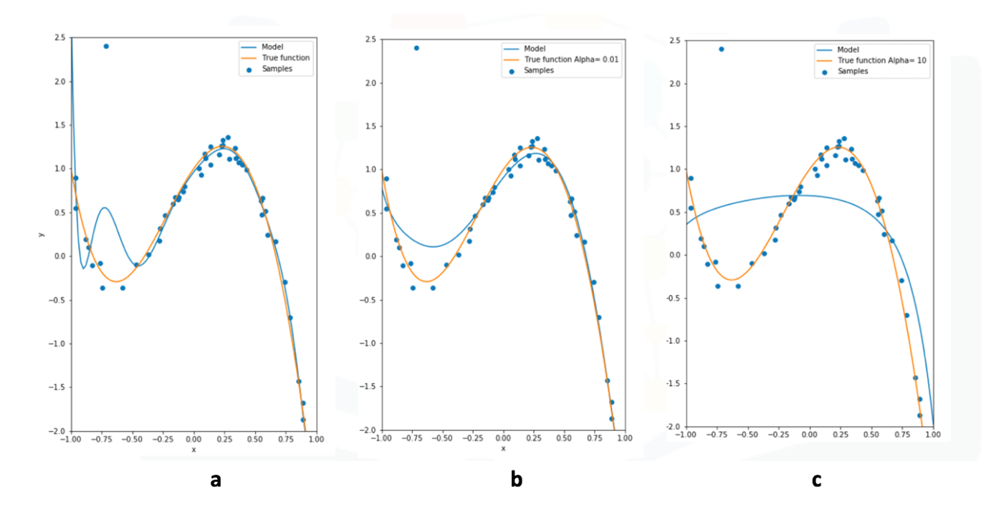



a



b



c

1 point

2.Question 2

the following models were all trained on the same data, select the model with the highest value for alpha:



**Correct C**